Лабораторная работа № 4

по дисциплине

“Объектно-ориентированное программирование”

Выполнил студент

группы БФИ1901

Бардюк Д.В.

Москва 2020

**Цель работы:** создать Java-приложение, которое сможет рисовать фракталы.

**Ход работы:**

import java.awt.geom.Rectangle2D;  
public class Mandelbrot extends FractalGenerator {  
 public static final int *LIMIT* = 2000;  
  
 public void getInitialRange(Rectangle2D.Double range) {  
 range.x = -2;  
 range.y = -1.5;  
 range.width = 3;  
 range.height = 3;  
 }  
  
 public int numIterations(double x, double y) {  
 ComplexNum cmplx = new ComplexNum(0, 0);  
 int iterator = 0;  
  
 while (iterator < *LIMIT* && cmplx.getSquaredModule() < 4) {  
 cmplx.makeSquaredInPoint(x, y);  
  
 iterator++;  
 }  
  
 if (iterator == *LIMIT*) return -1;  
  
 return iterator;  
 }  
}

import javax.swing.JComponent;  
import java.awt.*;  
import java.awt.image.BufferedImage;  
  
public class JImageDisplay extends JComponent {  
 private final BufferedImage image;  
  
 public JImageDisplay(int w, int h){  
 if (w <= 0)  
 throw new IllegalArgumentException("w must be > 0; got " + w);  
  
 if (h <= 0)  
 throw new IllegalArgumentException("h must be > 0; got " + h);  
  
 image = new BufferedImage(w, h, BufferedImage.*TYPE_INT_RGB*);  
 Dimension dimension = new Dimension(w, h);  
  
 super.setPreferredSize(dimension);  
 }  
  
 @Override  
 protected void paintComponent(Graphics g) {  
 super.paintComponent(g);  
  
 g.drawImage (image, 0, 0, image.getWidth(), image.getHeight(), null);  
 }  
  
 public void clearImage() {  
 Graphics2D imageGraphics = image.createGraphics();  
 imageGraphics.setColor(new Color(0, 0, 0));  
  
 imageGraphics.fillRect(0, 0, image.getWidth(), image.getHeight());  
 }  
  
 public void drawPixel (int x, int y, int rgbColor){  
 image.setRGB(x, y, rgbColor);  
 }  
}

public class ComplexNum {  
 public double rl;  
 public double im;  
  
 public ComplexNum(double rl, double im){  
 this.rl = rl;  
 this.im = im;  
 }  
  
 public double getSquaredModule() {  
 return (this.rl * this.rl + this.im * this.im);  
 }  
  
 public void makeSquaredInPoint(double x, double y) {  
 double real = (rl * rl) - (im * im) + x;  
 double imagine = 2 * rl * im + y;  
  
 rl = real;  
 im = imagine;  
 }  
}

import java.awt.*;  
import javax.swing.*;  
import java.awt.geom.Rectangle2D;  
import java.awt.event.*;  
  
public class FractalExplorer {  
 private int displaySize;  
 private JImageDisplay display;  
 private FractalGenerator fractal;  
 private Rectangle2D.Double range;  
  
 public FractalExplorer(int size) {  
 displaySize = size;  
  
 fractal = new Mandelbrot();  
 range = new Rectangle2D.Double();  
  
 fractal.getInitialRange(range);  
 display = new JImageDisplay(displaySize, displaySize);  
 }  
  
 public void createAndShowGUI() {  
 display.setLayout(new BorderLayout());  
 JFrame myframe = new JFrame("Fractal Explorer");  
  
 myframe.add(display, BorderLayout.*CENTER*);  
  
 JButton resetButton = new JButton("Reset Display");  
  
 Resetter handler = new Resetter();  
 resetButton.addActionListener(handler);  
  
 myframe.add(resetButton, BorderLayout.*SOUTH*);  
  
 Clicker click = new Clicker();  
 display.addMouseListener(click);  
  
 myframe.setDefaultCloseOperation(JFrame.*EXIT_ON_CLOSE*);  
  
 myframe.pack();  
 myframe.setVisible(true);  
 myframe.setResizable(false);  
 }  
  
 private void drawFractal() {  
 for (int x = 0; x < displaySize; x++) {  
 for (int y = 0; y < displaySize; y++) {  
  
 double xCoord = FractalGenerator.*getCoord*(range.x,  
 range.x + range.width, displaySize, x);  
  
 double yCoord = FractalGenerator.*getCoord*(range.y,  
 range.y + range.height, displaySize, y);  
  
 int iteration = fractal.numIterations(xCoord, yCoord);  
  
 if (iteration == -1) {  
 display.drawPixel(x, y, 0);  
 } else {  
 float hue = 0.5f + (float) iteration / 50;  
 int rgbColor = Color.*HSBtoRGB*(hue, 1f, 1f);  
  
 display.drawPixel(x, y, rgbColor);  
 }  
  
 }  
 }  
 display.repaint();  
 }  
  
 private class Resetter implements ActionListener  
 {  
 public void actionPerformed(ActionEvent e)  
 {  
 fractal.getInitialRange(range);  
 drawFractal();  
 }  
 }  
  
 private class Clicker extends MouseAdapter  
 {  
 @Override  
 public void mouseClicked(MouseEvent e)  
 {  
 int x = e.getX();  
 double xCoord = FractalGenerator.*getCoord*(range.x,  
 range.x + range.width, displaySize, x);  
  
 int y = e.getY();  
 double yCoord = FractalGenerator.*getCoord*(range.y,  
 range.y + range.height, displaySize, y);  
  
 fractal.recenterAndZoomRange(range, xCoord, yCoord, 0.5);  
  
 drawFractal();  
 }  
 }  
  
 public static void main(String[] args)  
 {  
 FractalExplorer displayExplorer = new FractalExplorer(800);  
 displayExplorer.createAndShowGUI();  
 displayExplorer.drawFractal();  
 }  
}

**Результат выполнения программы**

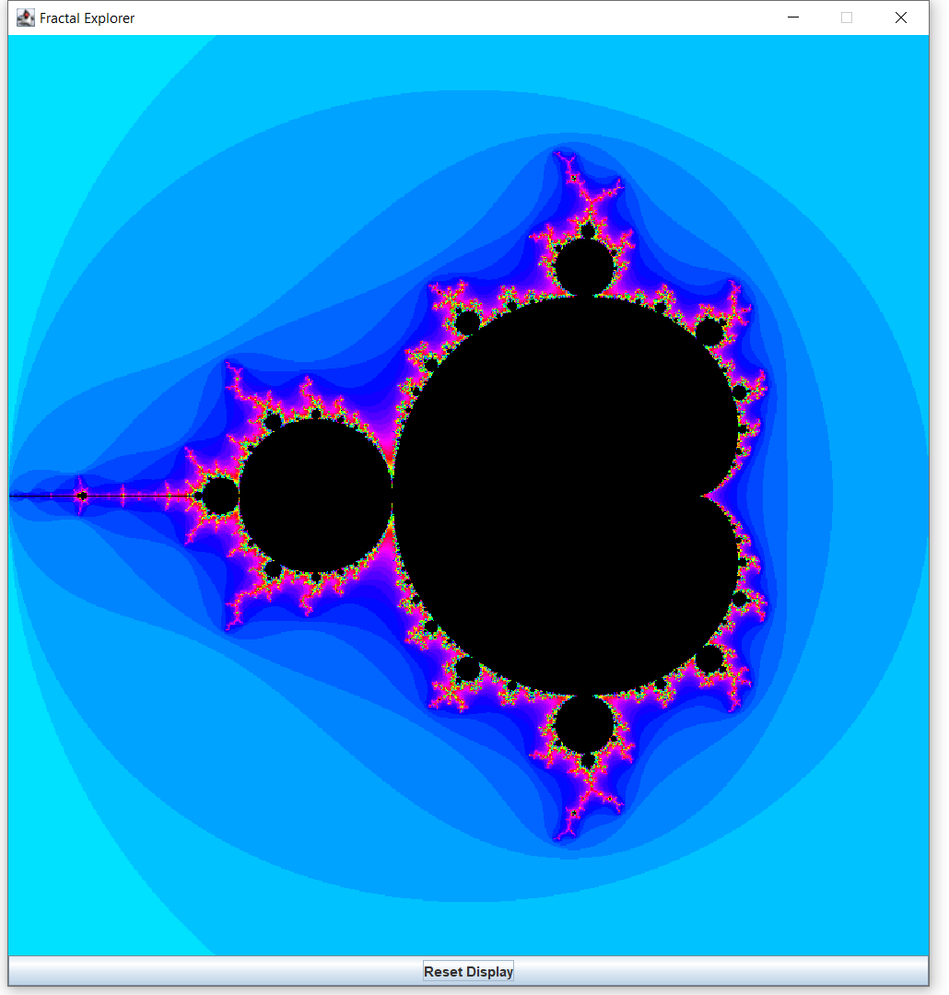

Ссылка на гит-репозиторий:

https://github.com/NillBard/Java/tree/master/%D0%9E%D0%9E%D0%BF